River Parkway Chiropractic - Massage Client Health History Intake

Please take a moment to answer the following questions. The information you provide will be used to customize your session to your needs, and exclude any techniques that may be medically unsuitable for you.

Name_____________________________________________ Date of Birth_______________ Male Female
Address_________________________________________________City/State/Zip_____________________________
Phone:(H)_________________________(W)__________________________Occupation_____________________Physician_____________________________Chiropractor_________________Referred By: ____________________
Emergency Contact & Phone: ____________________________________________________________________
Current Medications/OTC/Supplements & WHY:______________________________________________________
Please answer the following to the best of your knowledge.
1. Have you had a professional massage before? Yes No
2. Do you have allergic reactions to oils, lotions, or other substances put on your skin, or to any nuts? Yes No
3. Do you have any particular goals for this massage session? ______________________________________
4. If you are currently under medical supervision please explain: ______________________________________
5. Please check any condition/symptom listed below that applies to you:
Musculoskeletal System Nervous System Circulatory System Digestive System
Artificial Joint Alzheimer’s Atherosclerosis Crohns
Baker’s Cyst Herpes Zoster/Shingles Deep Vein Thrombosis (DVT) IBS
Bursitis Multiple Sclerosis Heart Attack Ulcers
Fibromyalgia or CFS Parkinson’s Disease High Blood Pressure Ulcerative Colitis
Muscular Dystrophy Peripheral Neuropathy Leukemia Other ________________
Osteoarthritis Seizures Low Blood Pressure
Osteoporosis Spinal Cord Injury Stroke
Plantar Fascitis Numbness Varicose Veins
Rheumatoid Arthritis Other __________________ Other __________________
Tendonitis
Whiplash
Other ________________

Lymph/Immune System Respiratory System Integumentary System (Skin) Miscellaneous Conditions
Allergic Reactions Asthma Athlete’s Foot Cancer
Chronic Fatigue Chronic Bronchitis Boils Depression
HIV/AIDS Sinusitis Burns Diabetes
Lupus Other _____________ Cold Sore/Herpes Easy Bruising
Lymphoma Dermatitis Headaches
Other ______________ Impetigo Migraines
Open Sores/Wounds Numbness
Psoriasis Pregnant
Rashes Other _______________
Warts
Other _______________

6. Please list any accidents or operations you have had and dates: ____________________________________

7. Please list any Sports/Regular Physical Activities you do: ____________________________________________

8. Please circle the level of physical activity you do: None Light Moderate Heavy

9. Please mark on the body forms with an “X” where you are experiencing any tension, stiffness or other discomfort. Please describe the sensation (burning, stinging, aching, pins-n-needles, etc.):______________________________________________________________________________________________

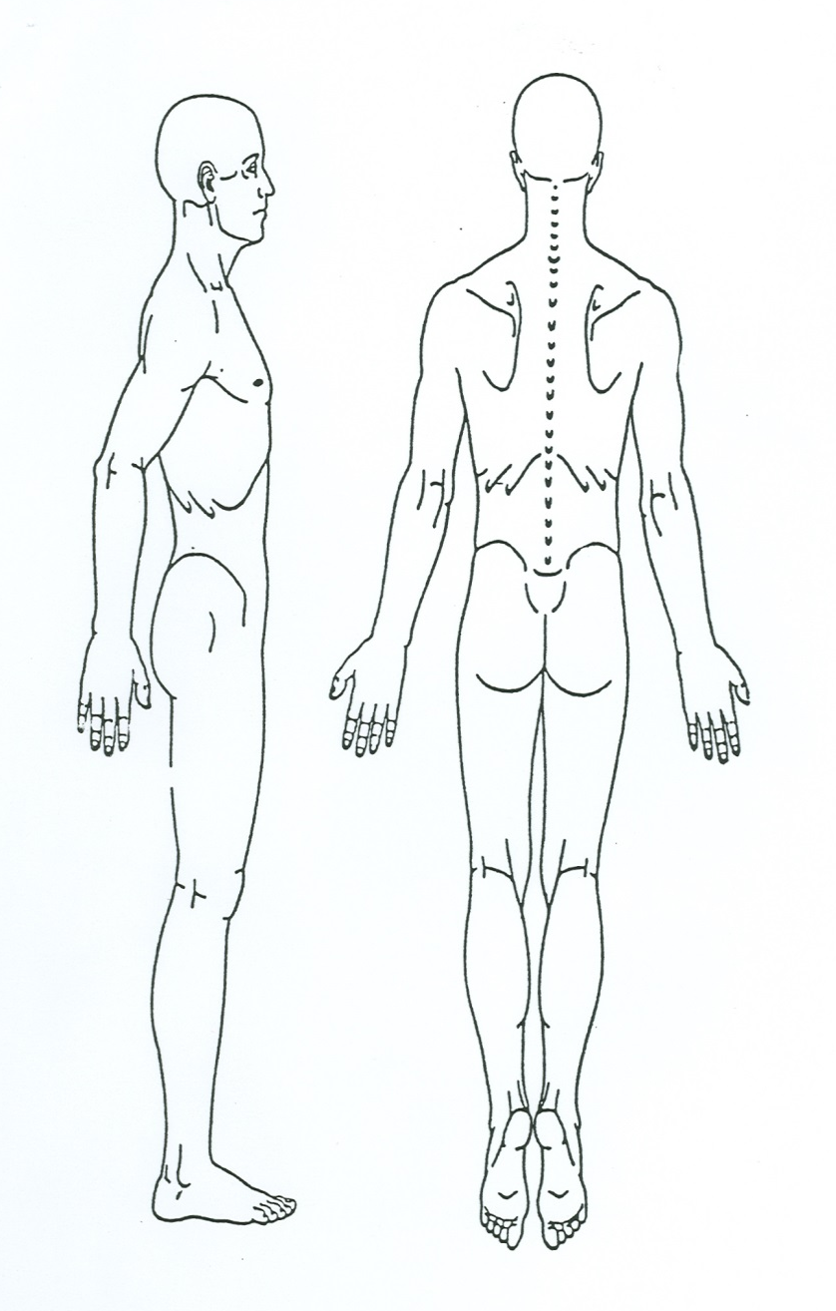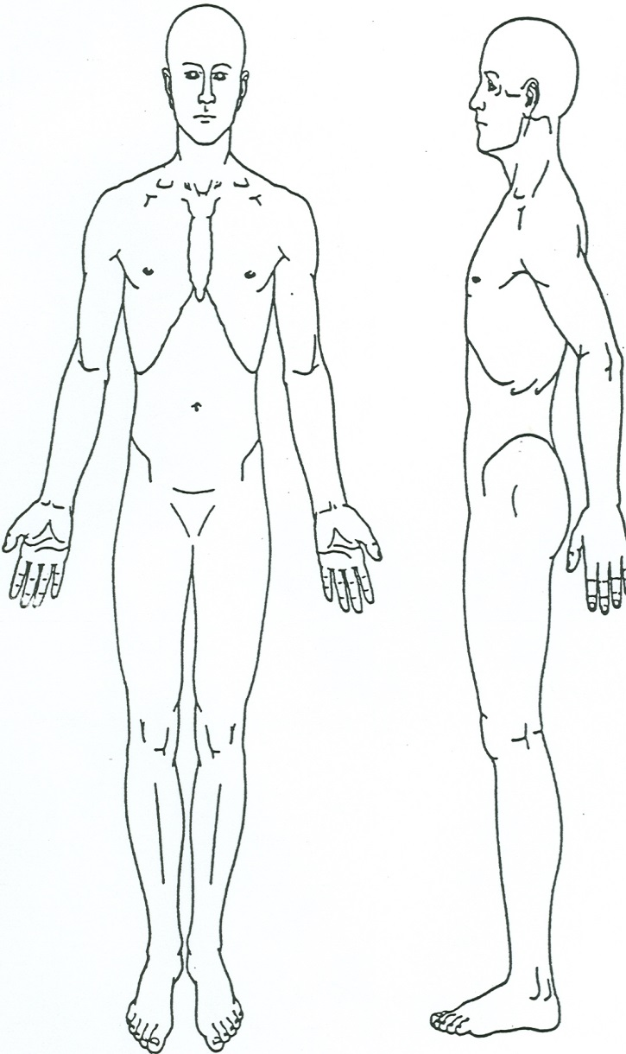
_______ (initials) I understand the massage therapy given here is for general wellness purposes, including stress reduction, relief from muscular tension or spasm, the promotion of circulation, lymph activity, and flexibility. I understand a massage therapist will never touch genitals, breast tissue, or any other areas I instruct them not to touch. I understand massage therapists do not diagnose illness, disease, or any other physical or mental disorder, do not prescribe medical treatment or pharmaceuticals, nor do they perform any spinal manipulations. I understand I should see a doctor or other appropriate health care provider for diagnosis and treatment of any suspected medical problem. I also understand that it is my responsibility to inform the massage therapist of any existing medical conditions I may have, and keep the massage therapist informed of any changes in my health and medications in the future. I understand that potential risks of massage include: mild, short term muscle soreness due to movement of irritating metabolic wastes; mild surface level bruising. I understand I have the right to refuse massage therapy treatment at any time during the session. Consent for Treatment: I authorize the performance of massage therapy techniques and procedures and understand that I will receive them from a certified massage therapist.

Client Signature_______________________________________________ Date________________________
Therapist Signature_______________________________________________ Date________________________

